**Application Deployment Options**

* We can deploy our application on
* Physical Server
* Virtual Machine
* Containers

**Physical Server vs Virtual Machine vs Containers ((Size, start-up and integration))**

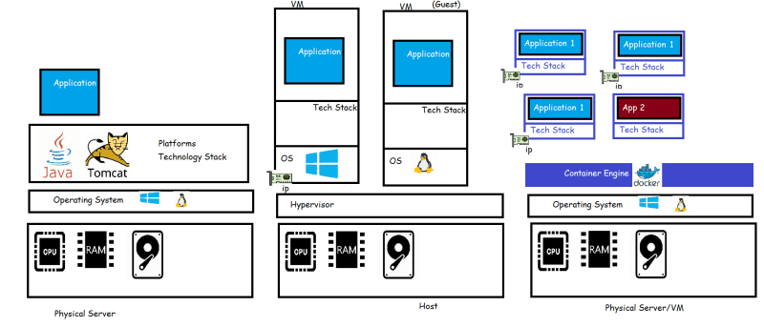

By experimenting we have understood, Container has everything which makes applications believe that they are running in OS

* CPU
* RAM
* network
* filesystem
* any other required stuff